**North Korean ship fleet**

Gorae

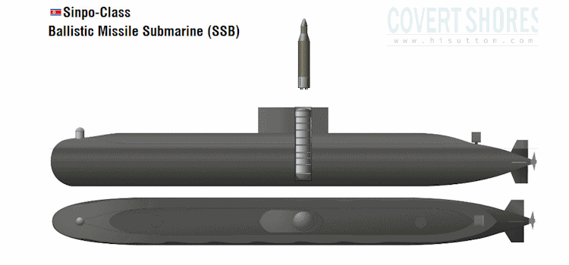Ballistic missile submarine.

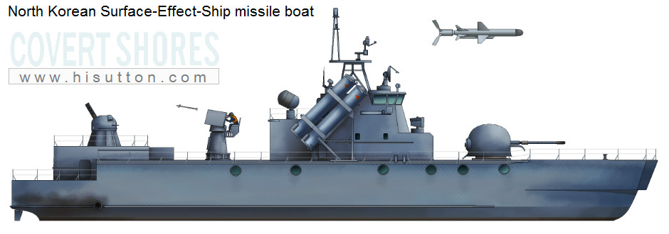Surface Effect Ship missile boat

Torpedo

DPRK VSV-32m

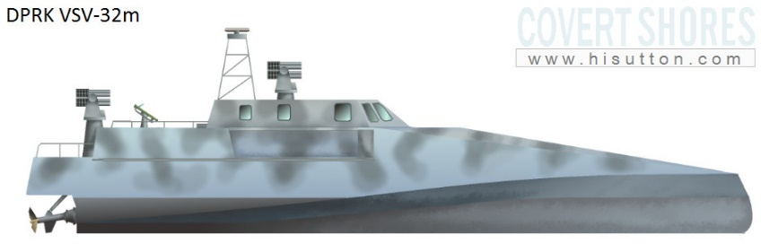

North Korea’s deadliest weapon: Cyber-attack. Possible control over enemies’ control system and allows player and extra go.